

**Packet Tracer – Configuring VLANs** (Instructor Version)

**Instructor Note**: Red font color or Gray highlights indicate text that appears in the instructor copy only.

## Topology

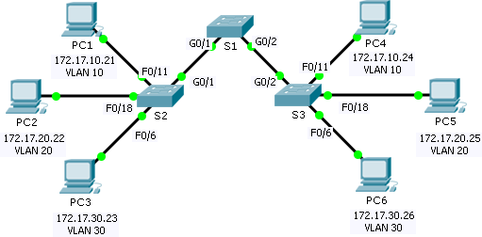

**Addressing Table**

|  |  |  |  |  |
| --- | --- | --- | --- | --- |
| **Device** | **Interface** | **IP Address** | **Subnet Mask** | **VLAN** |
| PC1 | NIC | 172.17.10.21 | 255.255.255.0 | 10 |
| PC2 | NIC | 172.17.20.22 | 255.255.255.0 | 20 |
| PC3 | NIC | 172.17.30.23 | 255.255.255.0 | 30 |
| PC4 | NIC | 172.17.10.24 | 255.255.255.0 | 10 |
| PC5 | NIC | 172.17.20.25 | 255.255.255.0 | 20 |
| PC6 | NIC | 172.17.30.26 | 255.255.255.0 | 30 |

**Objectives**

#### Part 1: Verify the Default VLAN Configuration Part 2: Configure VLANs

**Part 3: Assign VLANs to Ports**

**Background**

VLANs are helpful in the administration of logical groups, allowing members of a group to be easily moved, changed, or added. This activity focuses on creating and naming VLANs, and assigning access ports to specific VLANs.

# Part 1: View the Default VLAN Configuration

### Step 1: Display the current VLANs.

On S1, issue the command that displays all VLANs configured. By default, all interfaces are assigned to VLAN 1.

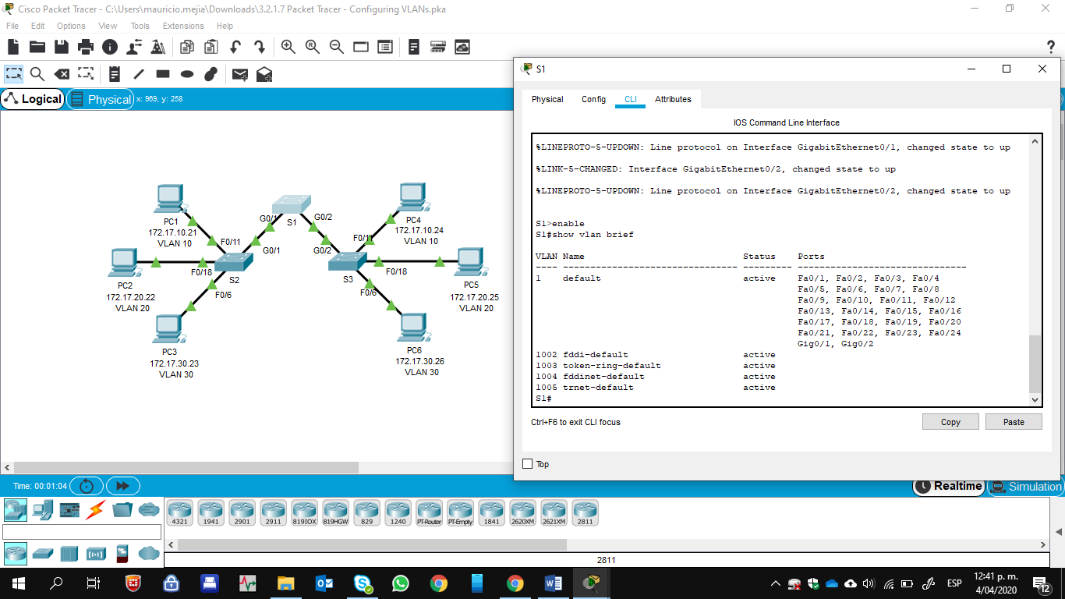

### Step 2: Verify connectivity between PCs on the same network.

Notice that each PC can ping the other PC that shares the same network.

* PC1 can ping PC4

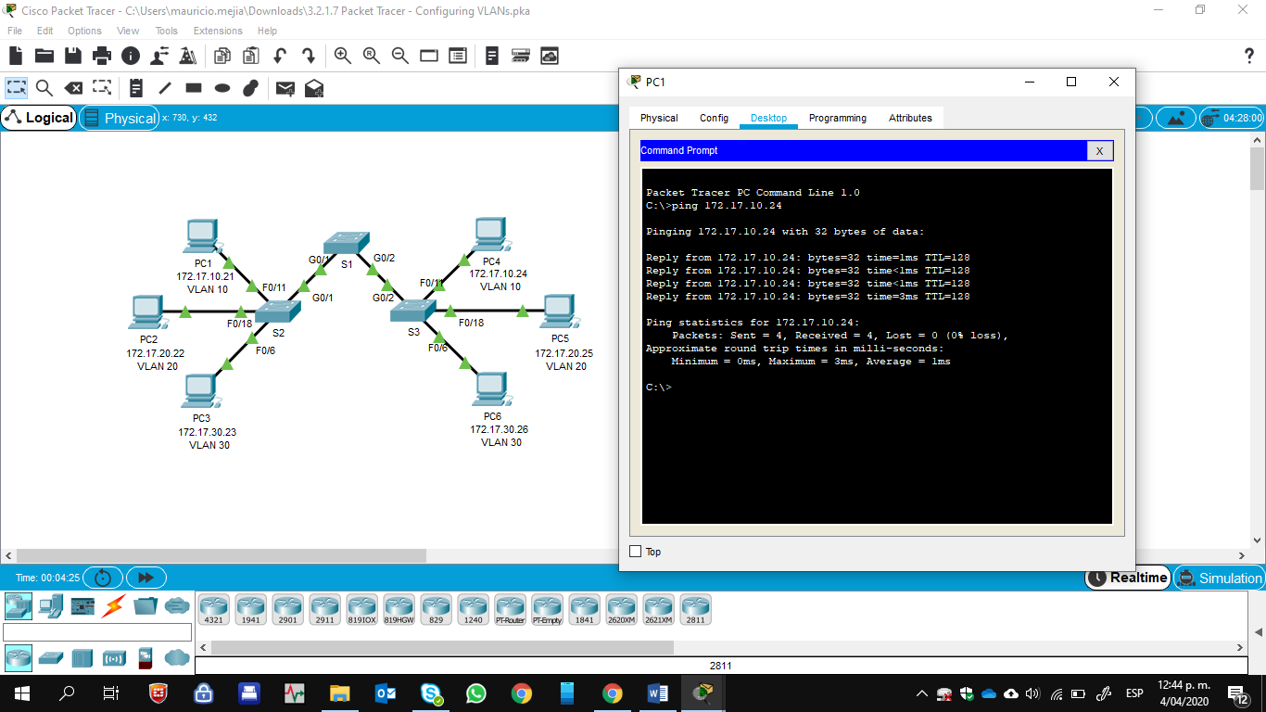

* PC2 can ping PC5

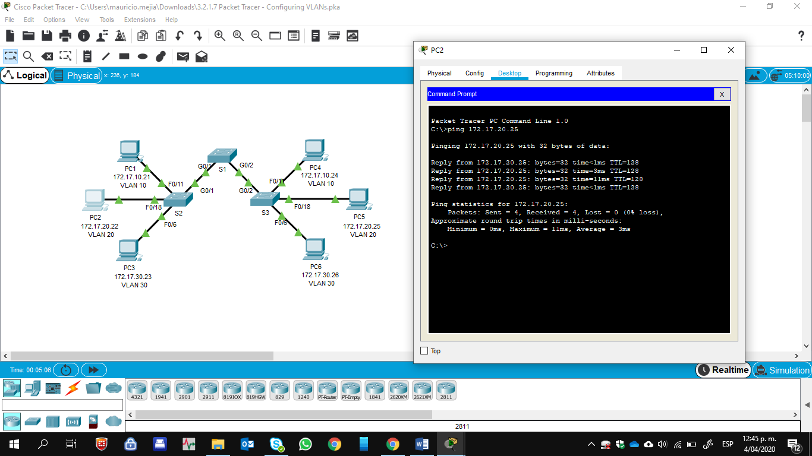

* PC3 can ping PC6

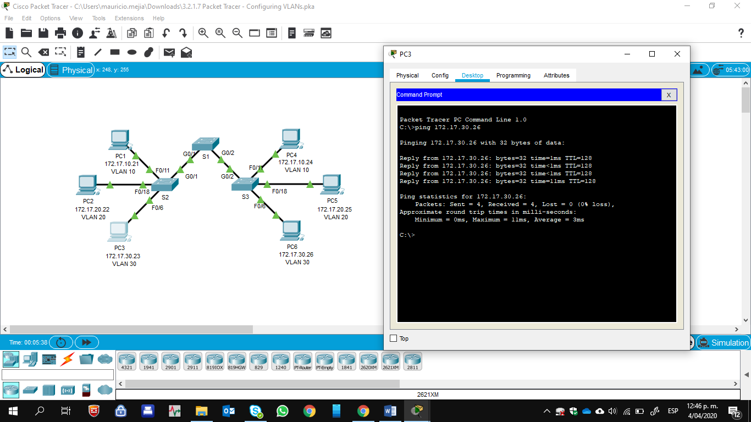

Pings to PCs in other networks fail.

What benefit will configuring VLANs provide to the current configuration? The primary benefits of using VLANs are as follows: security, cost reduction, higher performance, broadcast storm mitigation, improved IT staff efficiency, and simpler project and application management.

# Part 2: Configure VLANs

### Step 1: Create and name VLANs on S1.

Create the following VLANs. Names are case-sensitive:

* VLAN 10: Faculty/Staff
* VLAN 20: Students
* VLAN 30: Guest(Default)
* VLAN 99: Management&Native

S1#(config)# **vlan 10**

S1#(config-vlan)# **name Faculty/Staff**

S1#(config-vlan)# **vlan 20** S1#(config-vlan)# **name Students** S1#(config-vlan)# **vlan 30**

S1#(config-vlan)# **name Guest(Default)**

S1#(config-vlan)# **vlan 99**

S1#(config-vlan)# **name Management&Native**

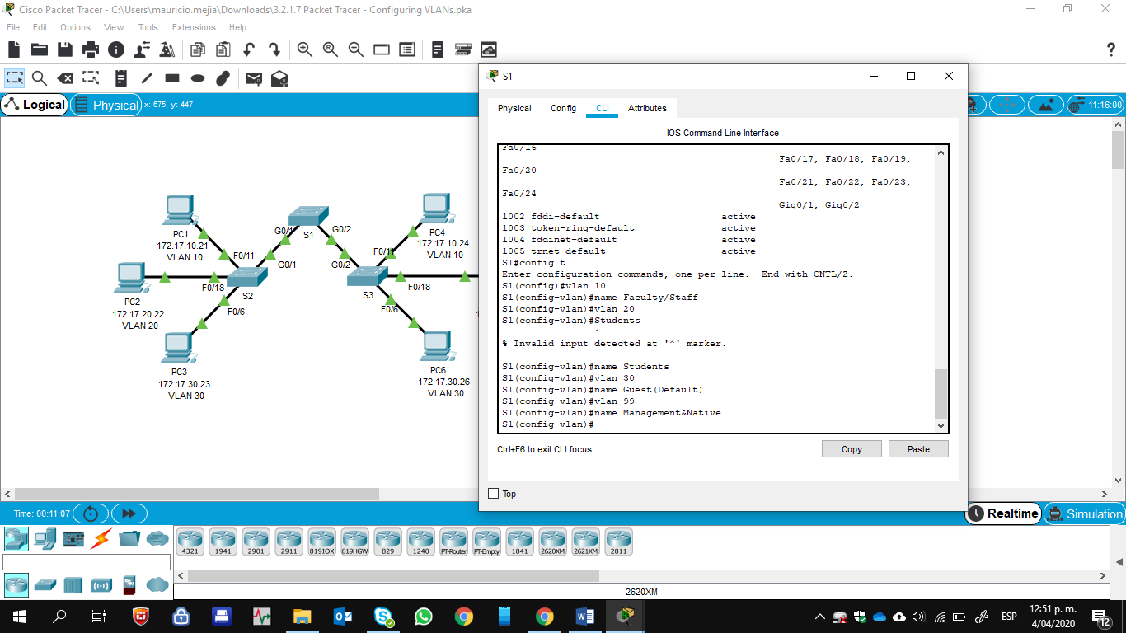

### Step 2: Verify the VLAN configuration.

Which command will only display the VLAN name, status, and associated ports on a switch?

S1# **show vlan brief**

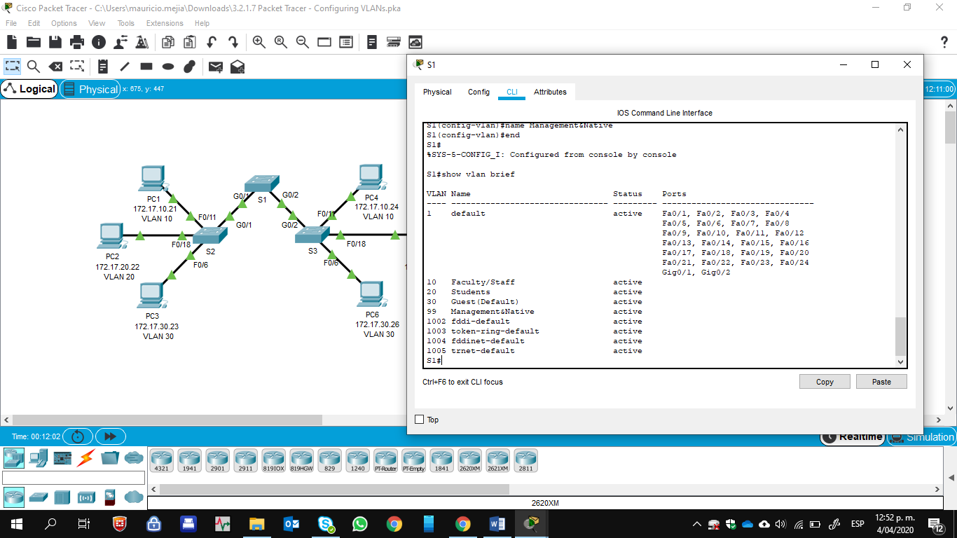

### Step 3: Create the VLANs on S2 and S3.

Using the same commands from Step 1, create and name the same VLANs on S2 and S3.

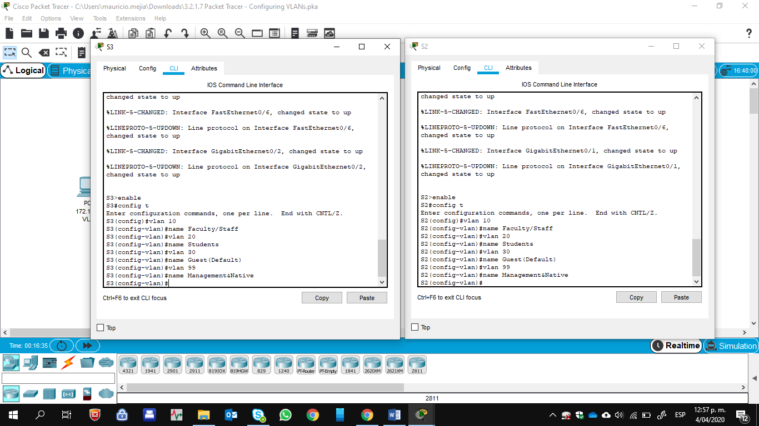

### Step 4: Verify the VLAN configuration.

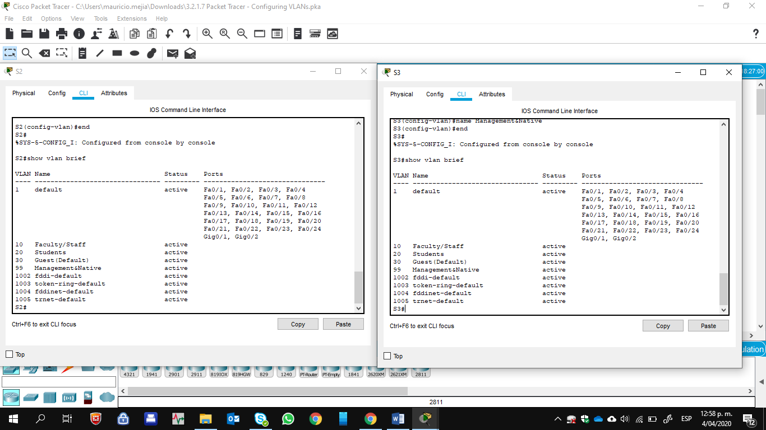

**Part 3: Assign VLANs to Ports**

**Step 1: Assign VLANs to the active ports on S2.**

Assign the VLANs to the following ports:

* VLAN 10: Fast Ethernet 0/11
* VLAN 20: Fast Ethernet 0/18
* VLAN 30: Fast Ethernet 0/6

S2(config)# **interface fa0/11**

S2(config-if)# **switchport access vlan 10** S2(config-if)# **interface fa0/18** S2(config-if)# **switchport access vlan 20** S2(config-if)# **interface fa0/6** S2(config-if)# **switchport access vlan 30**

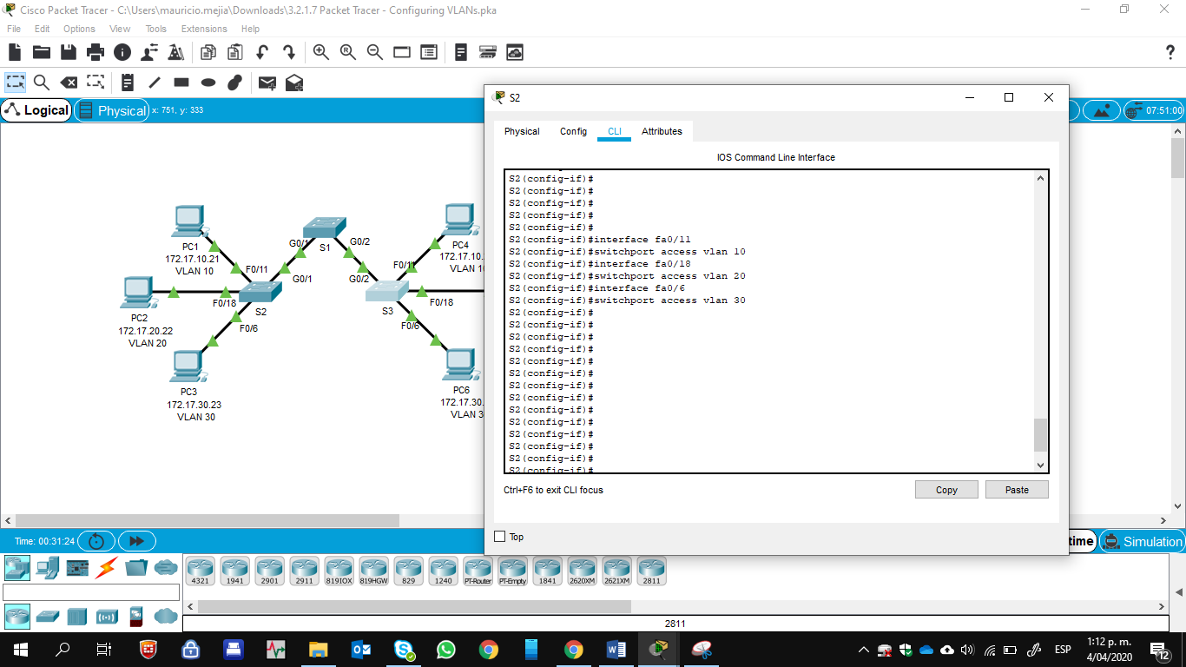

### Step 2: Assign VLANs to the active ports on S3.

S3 uses the same VLAN access port assignments as S2.

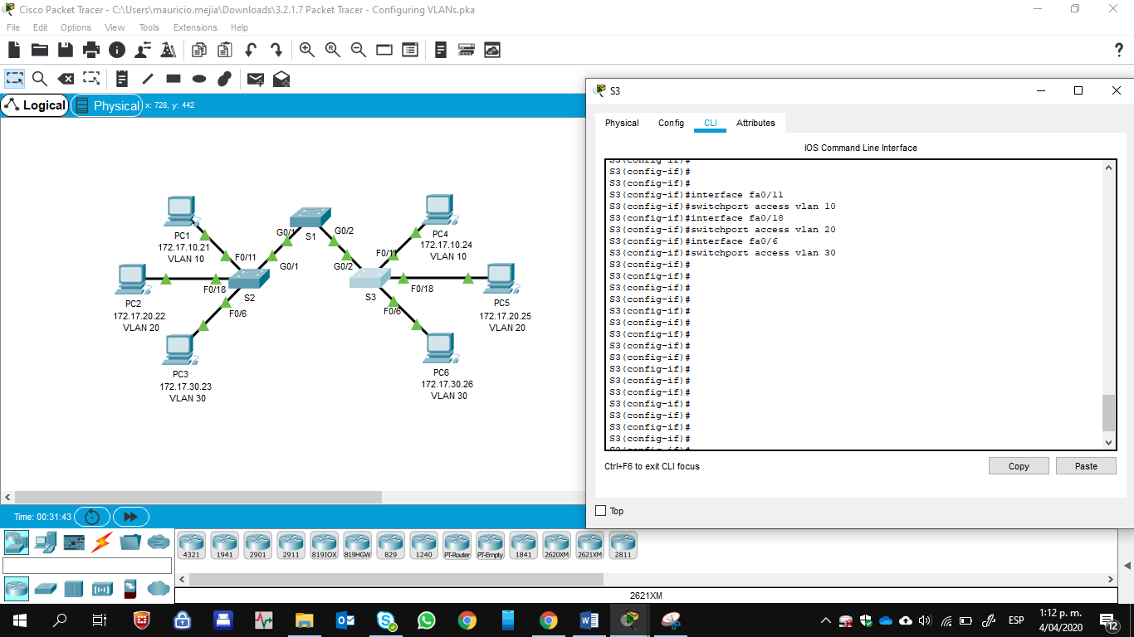

### Step 3: Verify loss of connectivity.

Previously, PCs that shared the same network could ping each other successfully. Try pinging between PC1 and PC4. Although the access ports are assigned to the appropriate VLANs, were the pings successful?

Why? No, the pings failed because the ports between the switches are in VLAN 1 and PC1 and PC4 are in VLAN 10.

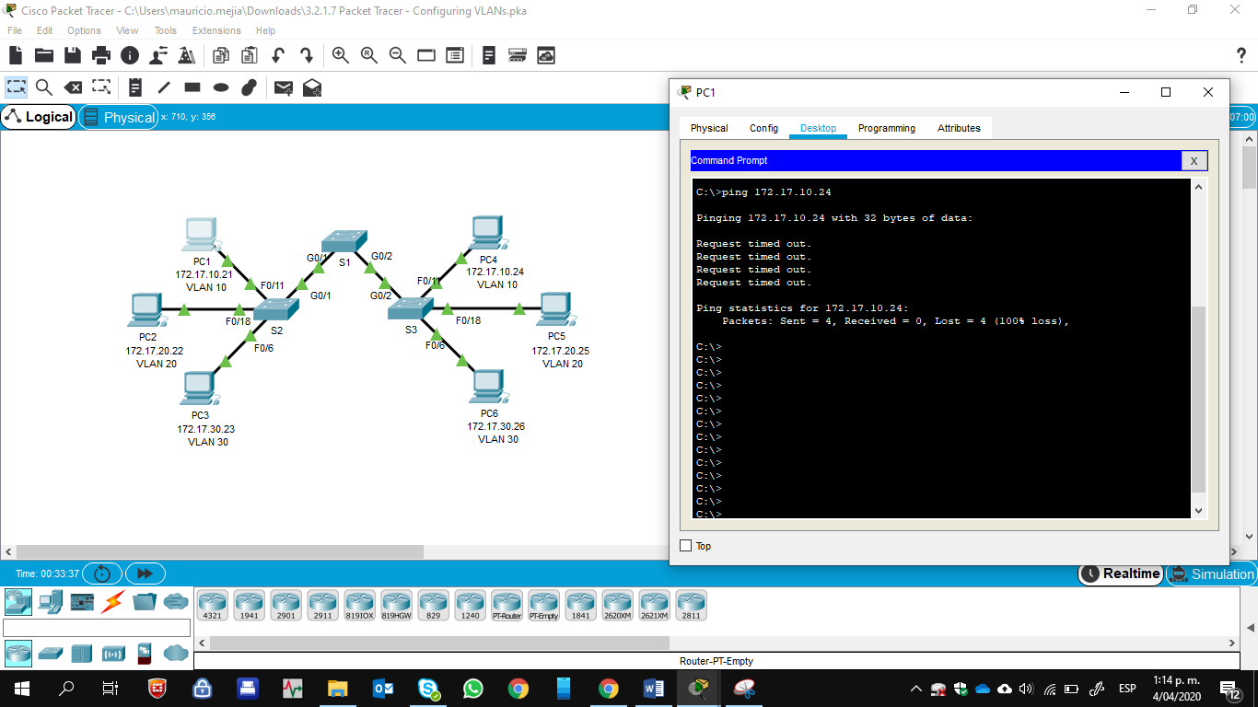

What could be done to resolve this issue? Configure the ports between the switches as trunk ports.

**Suggested Scoring Rubric**

|  |  |  |  |
| --- | --- | --- | --- |
| **Activity Section** | **Question Location** | **Possible Points** | **Earned Points** |
| Part 1: Verify the Default VLAN Configuration | Step 2 | **4** |  |
| Part 2: Configure VLANs | Step 2 | **2** |  |
| Part 3: Assign VLANs to Ports | Step 3 | **4** |  |
| **Packet Tracer Score** | | **90** |  |
| **Total Score** | | **100** |  |

